Westfield FFA
2022-2023
FFA HANDBOOK
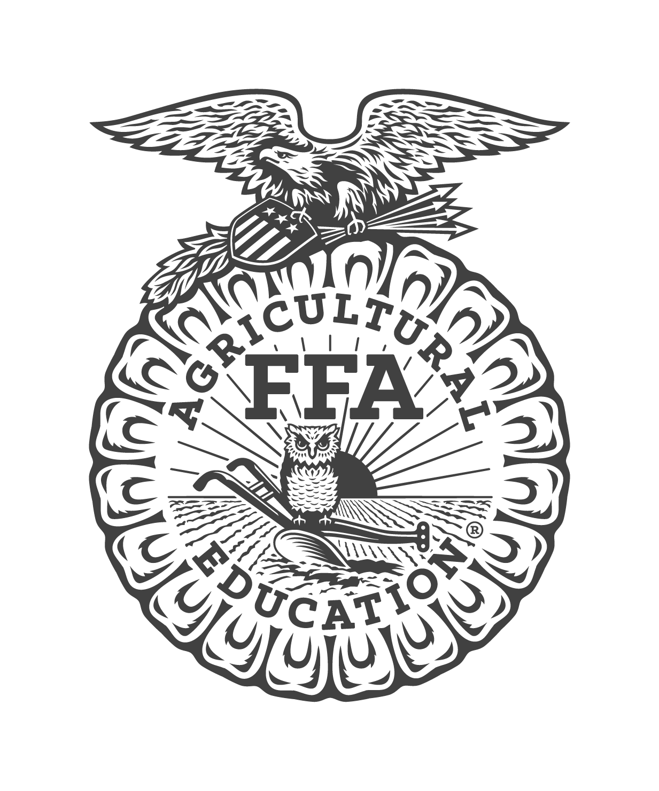
FFA CODE OF CONDUCT
FFA members should conduct themselves at all times to be a credit to their organization, family, chapter, school, and community.
FFA members should
- Communicate in an appropriate manner.
- Demonstrate good sportsmanship by being modest in winning and generous in defeat.
- Respect the rights of others and their property.
- Be courteous, honest, and fair with others.
- Dress neatly and appropriately for the occasion as outlined in the Westfield High School student handbook.
- Respect all Westfield faculty, staff, and students
- Follow all rules outlined in the FFA code of Conduct, Barn Rules/Contract, Officer Contact/Agreements, Westfield High School rules/Code of Conduct & applied program rules.

FFA member should NOT
- Receive any failing academic grades or lose Eligibility — Any student who is ineligible for 2 consecutive report cards will be issued a demerit following the 2nd consecutive failing report card until 1 week (7 days) after the last day of school. The failing class does not have to be the same as the failing class on the first two report cards.
- Receiving a failing grade on a report card will render a member ineligible (ineligible- unable to participate in any FFA contests, events, trips, Tri-Club, etc.). The member will remain ineligible until the start of the following grading period; grades will be reassessed at that time to see if eligibility will be regained. (Example: If a student fails on their report card, they may regain eligibility on the progress report if all grades are passing. If there is still a failing grade on the progress report, then the student will remain ineligible and grades will be reassessed at the report card.)
- Receive discipline referrals, detentions, ISS, or suspensions.
- Be a part of any robbery or theft.
- Assault or vandalize people or their property.
- Fight or be a part of a violent situation
- Use or be in the possession of fireworks or firearms of any type
- Be a part of sexual harassment situations
- Use unethical practices to create, raise, show, or exhibit their projects.
- Partake, possess, or be under the influence of alcoholic beverages
- Partake, possess, or be under the influence of tobacco or tobacco related paraphernalia.
- Partake, possess, or be under the influence of illegal substances.
- Use foul language at school or any FFA events
- Show disrespect to event officials, school faculty, staff, or fellow students
- Show disrespect to FFA advisors, officers, and members.
- Partake in inappropriate usage of social media platforms of any kind.

Consequences
(Students will receive Demerits for breaking the FFA code of Conduct, Barn Rules/Contract, Officer Contact/Agreements, Westfield High School rules/Code of Conduct & applied program rules)
1. First Demerit
- Warning is issued
- Notification to the parent or guardian (phone call and/or email)
- Notification to Westfield High School administration

2. Second Demerit
- Notification to the parent or guardian (phone call and/or email)
- Notification to Westfield High School administration
- Student is put on Probation until the end of the semester in which the demerit was given
- Possible removal of students from trips, activities, or events.

3. Third Demerit
- Notification to the parent or guardian (phone call and/or email)
- Notification to Westfield High School administration
- Loss of all FFA membership privileges
- Removal of student from FFA activities, events or teams (if the student is an officer, they will be removed from their officer team).
- Removal of an animal or exhibit from the Spring Tri-Club show and/or Ag facilities. The animal/exhibit will be declared ineligible for further participation in any events. Any student that is ineligible for the Spring Livestock Show has 72 hours, from the time of ineligibility notification, to remove their animal(s), projects, and belongings from the facility. Breeding animals will be given 7 days to move out. Projects/exhibits that are not removed in the time allowed will become property of Westfield FFA.
- Student loses all FFA privileges and membership status until the end of the school year (end of school year determined by Spring ISD calendar)
-Will be issued a discipline referral.
If misconduct occurs on a trip, upon returning to the school, consequences outlined in the school Student Code of Conduct Handbook will be enforced.

*Please note that if a violation occurs that is deemed serious enough by the Advisors and/or administration, they may move to immediately revoke membership privileges and/or remove projects/exhibits, as well as deem them ineligible.

Westfield FFA Membership Requirements
How to be a Member in Good Standing:
FFA members are required to maintain a "Good Standing" presence in order to be eligible for chapter functions, trips and opportunities. Outlined are the following requirements to maintain this status -
- Must be enrolled in an Ag class.
- Must pay dues required by the organization ($25). Failure to pay dues by the assigned deadline will result in late fees.
- Must Attend a MINIMUM of 2 Chapter meetings per academic year (banquet not included)
- Must participate in AT LEAST 1 (one) fundraising event (before Spring Tri-Club)
- Must sign and return all required documents issued by chapter/Advisors (including but not limited to FFA Handbook/Bylaws, Barn Contracts, grade checks, etc.)
- Must maintain academic eligibility
- Must maintain a clean discipline record with the school at all times (Suspension, ISS, discipline referrals, or detentions could result in demerits and/or the revoke of membership)
Failure to meet all of these requirements could result in the loss of member privileges, ineligibility/removal of animal and other projects, denial of FFA degrees, scholarship, or awards, loss of membership and/ or the prohibition of future membership.

Westfield FFA BY-LAWS
Section 1
Officers positions are open to all members. Members who wish to be considered
must apply and complete all phases of the election process. The final candidates will be selected by Advisors. Election process will be judges by individuals selected by the Advisors.
Section 2
The elected chairman of a committee may appoint members to serve with him.
Section 3
Gray’s Parliamentarian Guide for FFA shall govern the parliamentary procedure of
the chapter of all points not covered by the constitution and by-laws.
Section 4
A majority of the members of the organization shall constitute a quorum.
Section 7
Dues will be in accordance with the national, state, and area dues

FFA DUES
The dues are $25. This includes chapter, North District 1, Area 3, State, and National FFA dues. Members who pay after the assigned due date will incur a late fee (to cover late fees demanded by the State/National FFA Organization).

OFFICIAL DRESS FOR FFA
- The uniform that is worn by FFA members at local, state, and national functions is called official dress. It provides identity and a distinctive, recognizable image to the organization.
- Female members wear: White button up shirt with collar, black skirt (Pencil style, knee length) or pants, Official FFA scarf, black Pantyhose (full leg/coverage) Official FFA jacket, and black closed toed shoes (no Crocs or sneakers).
- Male members wear: Black pants, white button up shirt with collar, Official FFA tie, Black socks, black closed toed shoes (no Crocs or sneakers)
- Official FFA jacket- can be purchased from the National FFA at Shopffa.org.
- All members are strongly encouraged to purchase an Official FFA jacket, and Chapter Officers are required to have their own.
- Members who exhibit at the Spring Tri-Club show must be in Official Dress, including jacket.

By signing below, I acknowledge that I have read and understand all of the rules, requirements, and consequences listed in this document and agree to honor them. I agree to uphold these standards to the best of my ability and honor Westfield FFA with my actions.

Parent/Guardian Name: _________________________
Parent/Guardian Signature: _______________________
Student Name: _______________________________
Student Signature: ____________________________

